Bachelor of Engineering in Robotics and Artificial Intelligence

Team Project Module

Project Title: Alpha Mini

Group Progress Report 1

|  |
| --- |
| **Name** |
| Group Leader: |
| Member #1: |
| Member #2: |
| Member #3: |

Project Supervisor: Sarina Tajudin

Date: 25/09/2025

Words Count: 15284

(excl. Table of content/references)

**Abstract**

Write your abstract here.

**Table of Contents**

**Table of Contents**

**Type chapter title (level 1)1**

Type chapter title (level 2)2

Type chapter title (level 3)3

**Type chapter title (level 1)4**

Type chapter title (level 2)5

Type chapter title (level 3)6

**List of Figures**

Write your List of Figures here.

**List of Tables**

Write your List of Tables here.

**1. Introduction**

**1.1 Background**

Write a background of the current situation here. You may include photos, graphs etc here.

**1.2 Business Case**

Write the purpose / motivation to do this project.

**1.3 Aim and Objectives**

**Aim**

The aim of this project is to “Link back to your Project Title” (e.g if your Project Title is “Robot Nurse”, then your aim is “to program a Robot Nurse to be used in hospitals”)

**Objectives**

The objectives of this project are as follows:

1)

2)

3)

Remarks: Please come out with 3 to 5 objectives for this project. All objectives need to be met by the end of this module.

E.g Objectives:

1) To 3D Print additional robotic arm and to incorporate it into the Robot to allow better grasping of objects

2) To make use of the Robot’s Camera for facial recognition

3) To program the robot to be able to bend down and pick items if dropped

**1.4 Scope and Limitations**

**Scope**

The scope of this project are as follows:

1)

2)

3)

Remarks: Please come out with 3 to 5 Scopes. Scopes are steps you will take in order to achieve your objectives.

E.g Scope:

1) To use Fusion 360 software to create the 3D Model of the arm

2) To programe the Robot using Python

3) To set the limits of the motors to allow Robot stable movement and bending

**Limitations**

The limitations of this project are as follows:

1)

2)

3)

Remarks: Please come out with 3 to 5 Limitations. Limitations are things which you will not be researching or doing in this project.

E.g Limitations:

1) This project will not look into using ROS for programming

2) The camera used is able to detect objects at 1m range only

3) The max load that the robot is able to carry is 1kg.

**1.5 Key Deliverables and Milestones**

**Key Deliverables**

The key deliverables for this project are as follows:

1)

2)

3)

Remarks: Please come out with 1 to 3 Key Deliverables. Deliverables are concrete, tangible results that are produced by the project such as test results, prototypes, etc

E.g Key Deliverables:

1) Robot is able to shorten medicine dispensing time by 30minutes.

2) Robot is able to recognise the patient and prescribe the correct medicine

3) Robot is able to dispense medicine safely without dropping the medicine.

**Milestones**

The Milestones for this project are as follows:

1)

2)

3)

Remarks: Please come out with 1 to 3 Milestones. A milestone is a scheduled event (a moment in time) signifying the completion of a major deliverable or a set of related deliverables.

E.g Milestones:

1) To complete fabricating arm prototype by 30 June

2) To complete programming facial recognition feature by 30 July

3) To complete programming medicine dispensing behaviour by 30 August

**1.6 Work Breakdown Structure**

Write your work breakdown structure here.

Remarks: WBS is a visual, hierarchical and deliverable-oriented deconstruction of a project.

E.g

Figure xxx: Write your Figure name here

**1.7 Schedule**

Please use Excel Gantt Chart to come up with “to do list” for each week. Set the page orientation into landscape.

Example (follow same format, do not copy):

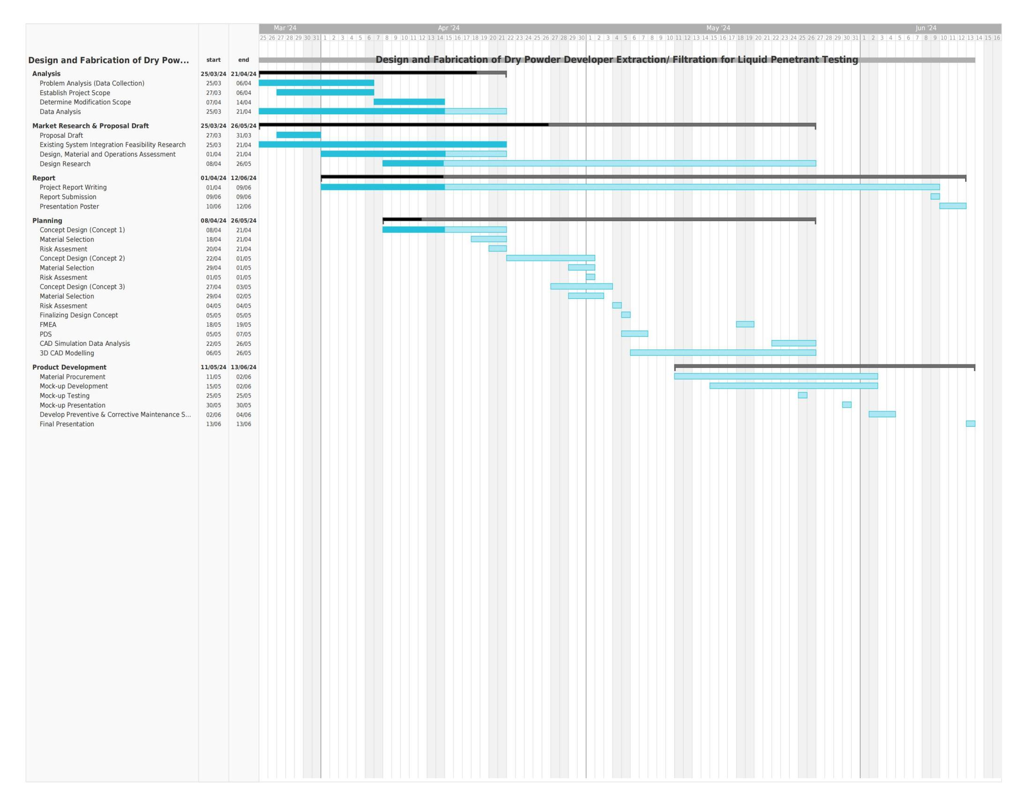

Figure xxx: Write your figure name here

**1.8 Communication Channel for Coordination**

Indicate your communication channel here (e.g Whatsapp).

Attach a picture of your group (e.g Whatsapp group) with all the members here.

**1.9 Setting up private repository for Software version control**

Indicate your private repository here (e.g GitHub).

Attach a picture of your group (e.g GitHub) with all the members here.

**1.10 All team member signature**

|  |  |
| --- | --- |
| Name | Signature |
| Monish Naresh |  |
| La Min Aung |  |
| Cornelius Fulvian |  |
| Joseph Santhosh Aaron |  |